**Major Project**

**Health Care Website**

Why do we need a health care website?

Healthcare is an industry tailor-made for content marketing. Customers will always have questions, and there must be someone to answer them. So, why not do it effectively — on our website? By creating an online platform, we will contribute considerably to future prosperity. This need for an online presence can be explained by a number of reasons:

* *Long lines at reception*
* *Long waits for lab results*
* *High levels of medical appointment fees*
* *Expansion of epidemic and viral diseases* due to hospital overcrowding

Evidently, overcrowding is the whole point. This issue, as distinct from healthcare pricing, is not too deeply seated and yet can be addressed. Any health facility, be it a small clinic or a large hospital, stands a chance of benefiting from going online.

A successful online platform (a website) has to connect a provider of services (a hospital) with its customers (patients.)

Purpose of Health Care Website:

* ***Consumer education***
* ***Disease management***
* ***Clinical decision support***
* ***Physician-consumer communication***
* ***Administrative efficiencies***

Each of these components relates to the idea of the doctor-patient relationship. At the same time, they can be associated with specific types of medical sites. Website contain useful and reliable information.

Let’s now take a closer look at the requirements of health care websites.

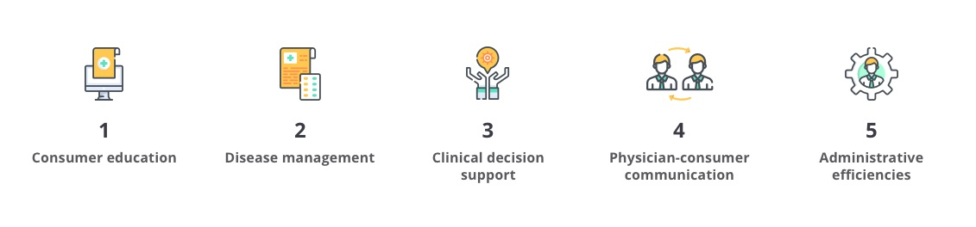

**1. Consumer education.**

Most patients are ignorant of treatment details and do not know much about their current condition. To help your patients, you can create a website that offers information about disease prevention, risk factors, and tips on how to reduce treatment costs.

**2. Disease management.**

This kind of website will be especially useful for patients suffering from chronic diseases. Due to the “Ask a physician/nurse” feature that many web-based health portals have, customers can evade visiting their physicians too often and track their medical condition by taking advantage of Internet-based technologies.

**3. Clinical decision support.**

Web-based clinical decision support systems as a means of medical error reduction can help health workers access different databases. These systems would allow finding necessary information quickly to make the problem-solving process more efficient.

**4. Physician-consumer communication.**

One of the most convenient ways to connect to your doctor is by email. This can be done through either the eHealth portal or the doctor’s own website. In both cases, patients use a Web interface to send an email and get a prompt response.

**5. Administrative efficiencies.**

Some people would say that this is the largest benefit they can derive from a medical website. Through web-enabled processes, health facilities and patients will save time, money, and even lives: filling forms online and computerized pharmacy ordering, to name a few.

**Website Design**

